Name ______________________________ Homework April 11-15
Module 8 Week 1

Put your initials by each night that your child practiced the following:
____Monday ____Tuesday ____Thursday
*Nightly Homework*
1. Read Start Right Reader page.
2. Count numbers 1-100.
3. Practice assigned Sight Word list in red reading folder.

Monday: Read each word. Add an e to the end and draw a picture of the new word.

fiv__ kit__ nin__ tap__ rak__

hen | get | fed | pen | ten | pet | jet | wet | let
_____ | _____ | _____ | _____ | _____ | _____ | _____ | _____ | _____
_____ | _____ | _____ | _____ | _____ | _____ | _____ | _____ | _____
_____ | _____ | _____ | _____ | _____ | _____ | _____ | _____ | _____
Tuesday: Write each spelling word three times.

Color a circle for each sound you hear in the word.
sled  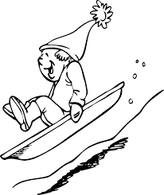 | bike  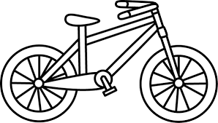 | stop  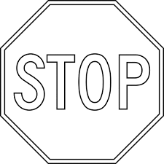 | slide  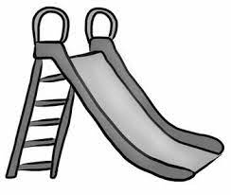

Thursday: Color the picture and write 2 sentences about it.

_____________________________________________________________

_____________________________________________________________

_____________________________________________________________

Words to Know

know out same take

Bake Shop
Kate fills a wide pan with cake mix. She slides it in to bake. “Mike, it will take time to bake,” said Kate. Mike gets games to fill the time. At last! Kate slides out the lime cake. But it is in a bad state! Mike gave it to the hens. Peck! Peck! Peck! Six white hens ate it up. “Hop on your bike, Mike,” said Kate. “We can ride to the bake shop.” At the bake shop, Kate picks lime cake. “Same for me!” yells Mike. At last! They ate lime cake.

Talk about the story and answer the questions:
Who are the characters in the story? What does Kate do with the cake mix? What do they do while the cake bakes? What does “it is in a bad state” mean? Who ate the cake? How do Mike and Kate go to the bake shop? What do they eat at the bake shop?

